Constitutional Notice, Complaint, and Demand, regarding: U.S. Const. art. I § 2; U.S. Const. amen. VII; U.S. Const. amen. X; U.S. Const. art. VI cl. 3; Colo. Const. art. VII § 1; Colo. Const. art. II § 5; Colo. Const. art. VII § 1; Colo. Const. art. VII § 11.

Statement of True Facts
It is law that Notice to Agent is Notice to Principal; Notice to Principal is Notice to Agent.

To: Weld County Clerk Carly Koppes
1250 H St
Greeley, Colo. 80631

Ms. Carly Koppes:

During the 2021 election from 10/25/21 to 11/2/21 in Weld County, Clerk Carly Koppes violated multiple fundamental constitutional rights of multiple Colorado citizens, all in violation of her oath of office and in violation of law. In the process of these violations, they violated multiple Colorado Revised Statutes, Code of Colorado Regulations, and Weld County Home Rule Charter Rules. In this document we will: (1) present “The Statement of True Facts,” of these violations, (2) provide a written copy of the exact rights, statutes, and rules violated, and (3) serve notice of our, “Constitutional Complaints and Demands,” for relief from these unlawful actions committed by Clerk Carly Koppes.

Prior to the 2021 election, the Republican Party (GOP) Election Integrity Program (EIP) organized and rolled out a training program for Poll Watchers. Poll Watches: (1) Amy Miller, (2) DeAnn Jacobs, (3) Shelley Rowe, (4) Pam Stoll, (5) Rick Nevin, and (6) Linette Ballew received training certificates of completion from the Secretary of State (SOS), obtained appointments from candidates, and received Certificates of Appointment under Colo. Rev. Stat. 1-7-107 and 8 Colo. Code Reg. 1505-1 Rule 8.1 that were signed by SOS Janet Griswold and Clerk Carly Koppes. This qualified each of these Poll watches with the credentials as “Watchers” under Colo. Rev. Stat. § 1-7-108 and Colo. Code Reg. 1505-1 Rules 8.1, 8.4, and 8.5. By statute and regulation, these “Watchers” are allowed access to the voting process by Colo. Rev. Stat. § 1-5-503 and Colo. Code Reg. 1505-1 Rules 8.6, 8.8.3, 8.10, 8.11, 8.12, 8.13, 8.14 and 8.15.
We will chronicle violations of both Colorado Revised Statutes and Colorado Code Regulations perpetrated against these six Poll watchers. We are not limiting this notice to violations of statutes or code rules, but more importantly, to violations of our rights granted under both the U.S. Constitution and the Colo. Constitution identified at the top of each page of this document. These violations are grouped by Polling Location, Date of offense, and person violated.

Trinity Lutheran Church:
October 25, 2021:
Amy Miller:
Amy’s chronicle of this incident begins with her being greeted by Jamie Presgrove, the Poll Watcher Contact at this Weld County Voting Service and Polling Center (VSPC). Amy signed the Certificate of Appointment in Presgrove’s presence and presented it to her as proof of her standing as a “Watcher.”

Amy chronicles:
“I was offered a seat in the ‘Watcher Seating Area’ against a wall and was expected to stay seated at all times. I asked Jamie if I could see the Election Judges’ screens, and she said, ‘No...’ “At the Provisional table there is not enough room to stand behind the Election Judges… I asked Jamie who set the room up? She said the Weld County IT person (Adam and/or Jason) set up the voting room and where all the tables, voting booths, etc. would be placed… talking with Jamie (sic) I came to realize that she didn't know my rights as a poll watcher and that poll watchers were not prioritized. She said the priority was: the rights of the election judges to do their job, the rights of the voters to vote and then, if it worked, the poll watchers could request their rights. She said she had the right to say no to my rights as a poll watcher... she (Jamie) was told that, ‘we couldn't see what the election judges were doing even though her training said otherwise.’ ”

These constraints on Amy were in violation of Colo. Rev. Stat. § 1-5-503, 8 Colo. Code Reg. 1501-1 Rule 8.10.2(a)(2), 8 Colo. Code Reg. 1501-1 Rule 8.10.2(a)(8), 8 Colo. Code Reg. 1501-1 Rule 8.10.2(b), and the Colo. Const., art. II, § 5, providing for “free and open elections.” While being pinned to this location in the room, Amy, a certified watcher, was not granted access to the election process such that she could “attest to the accuracy of election-related activities.” She could neither see the judge’s computer screens nor hear the conversation between voter and judge, in violation of Amy’s rights and of law. The statement to Amy by Jamie, the Poll Watcher Contact, that, “… she had the right to say no to my rights as a poll watcher,” exhibits either ignorance or fraud. Human rights are only granted by God and enumerated in the Colorado Constitution. Jamie violated Amy’s rights.

October 26, 2021:
Shelley Rowe:
Shelley’s chronicle of this incident states:
“According to 8 Colo. Code Reg. 1501-1 Rule 8.10.2(b), Poll Watchers in Colorado are allowed to witness and verify means to personally observe actions of election officials in each step of the conduct of an election, but when we (another Poll Watcher was with Shelley) Poll Watchers were not allowed to stand behind the Judges and watch because we, the Poll Watchers, may not see the personal information of voters that the Judges can see. I brought a printed copy of Rules 8 and 8:10(b) and read it to Jamie. She made a phone call to Carly, the Weld County Clerk & Recorder, and Carly told her that she would come out to the VSPC location to talk with us. So I waited for Carly to arrive and talked life with Jamie while we were waiting. While we talked, I sat in the designated Poll watcher chairs where Jamie told us we could sit to observe the entire room as Poll Watchers. The judges table was approximately 25 feet to the right, as we were sitting down… (on the) designated Poll Watchers chairs. The check in table, to our left, was a little further away, approximately 30 feet away, and the polling stations for both paper and electronic voting were straight ahead of us approximately 20 feet. Jamie did say we could walk around the room, staying at least 6 feet from any voter that was using the voting stations. But we were not allowed to stand behind the Judges. Carly arrived at approximately 1:45 pm (45 minutes after our arrival) and verbally told us, ‘Poll Watchers are not allowed to stand behind the Judges and watch what they do.’ I then read her 8 Colo. Code Reg. 1501-1 Rule 8.10.2(b), and said I was confused because I thought this was a State of Colorado Rule. Carly said it was the State Rule, but the County Clerk’s are allowed to set their own rules, and Weld County has a written plan that spells out the fact that Poll Watchers cannot stand behind the Judges and Watch. She referred us to look at the Weld County Clerk and Recorders website to find that plan… When I got home, I searched the Weld County Clerk & Recorder website for about 30 minutes, but was unable to find the Weld County Poll Watcher Plan, so I emailed Carly and told her I could not find it on the website and asked that she email it to me.”
Clerk Carly Koppes emailed this plan to Shelley.

These constraints on Shelley were in violation of Colo. Rev. Stat. § 1-5-503, 8 Colo. Code Reg. 1501-1 Rule 8.10.2(a)(2), 8 Colo. Code Reg. 1501-1 Rule 8.10.2(a)(8), 8 Colo. Code Reg. 1501-1 Rule 8.10.2(b), and the Colo. Const., art. II, § 5, providing for “free and open elections.” While being pinned to this location in the room, Shelley, a certified watcher, was not granted access to the election process such that she could “attest to the accuracy of election-related activities.” She could neither see the judge’s computer screens nor hear the conversation between voter and judge, in violation of Shelley’s rights and of law.

October 30, 2021:
DeAnn Jacobs:
DeAnn’s chronicle of this incident states:
“She (Jamie) showed me all around, explained the functions. I could not get behind the computer table (Judge’s table) as it was basically up against the wall. I asked her why I could not go behind and she said that the set up of the room was laid out by the SOS, and I should look a the diagram for Weld County.”

These constraints on DeAnn were in violation of Colo. Rev. Stat. § 1-5-503, 8 Colo. Code Reg. 1501-1 Rule 8.10.2(a)(2), 8 Colo. Code Reg. 1501-1 Rule 8.10.2(a)(8), 8 Colo. Code Reg. 1501-1 Rule 8.10.2(b), and the Colo. Const., art. II, § 5, providing for “free and open elections. She could neither see the judge’s computer screens nor hear the conversation between voter and judge, in violation of DeAnn’s rights and of law.

UNC:
November 1, 2021:
Pam Stoll:
Pam chronicles:
“When I attempted to stand behind the judge(s) at the Computer Table, Dan made it very clear that I was not allowed to be there and basically ‘herded’ me back to the chairs. My time assignment was about done so I left the building and called Lois to report the issue.”

These constraints on Pam were in violation of Colo. Rev. Stat. § 1-5-503, 8 Colo. Code Reg. 1501-1 Rule 8.10.2(a)(2), 8 Colo. Code Reg. 1501-1 Rule 8.10.2(a)(8), 8 Colo. Code Reg. 1501-1 Rule 8.10.2(b), and the Colo. Const., art. II, § 5, providing for “free and open elections.” She could neither see the judge’s computer screens nor hear the conversation between voter and judge, in violation of Pam’s rights and of law.

DeAnn Jacobs:
DeAnn’s chronicle of this incident states:
“… I went behind the table to see the computer screens. Dan got very agitated that I was there, told me I was not allowed to be behind the judges. I told him, yes I am allowed and handed him the Rule 8 paperwork. He said, no, you are not allowed to see people’s personally identifiable information. I said yes, I am allowed, and I can write down their names, addresses, and voter ID. Only if they are a Confidential Voter, then I cannot write that down, but I am allowed to see. We went back and forth, him trying to maneuver me away, me trying to see. He said I could write her name down from the log book, so I did…. I asked Dan to call and verify the meaning of Rule 8, he called Adam, Deputy Clerk, and he said no, as a watcher we cannot be behind the computer tables.”

The constraints laid on DeAnn were in violation of Colo. Rev. Stat. § 1-5-503, 8 Colo. Code Reg. 1501-1 Rule 8.10.2(a)(2), 8 Colo. Code Reg. 1501-1 Rule 8.10.2(a)(8), 8 Colo. Code Reg. 1501-1 Rule 8.10.2(b), and the Colo. Const., art. II, § 5, providing for “free and open elections. She could neither see the judge’s computer screens nor hear the conversation between voter and judge, in violation of DeAnn’s rights and of law.

Del Camino:
November 2, 2021:
Linette Ballew:
Linette chronicles:
“After our discussion about being allowed behind the (Judge’s) tables, I approached the head judge regarding the info. I showed her the printed rules I had with me and explained that an updated email had recently been sent out. I explained that per her rules to not use my phone I missed calls regarding this, but now wanted to check my phone and show her the email. One of those behind the computer said, ‘I was told if she's back here to close my computer. She can't see.’ Head judge had me wait while she made a call to verify my information. Upon her return I showed her the updated email from WCCR. She stated that earlier in the day they were instructed to not allow PWs back in that area, but that apparently that rule had changed and agreed that I could indeed be anywhere as long as I stayed 6 feet away from the voters.”

Linette’s account documents that at the end of the 2021 election cycle, that Weld County Clerk Carly Koppes changed the rules to allow Poll Watchers to exercise their constitutional rights.

Ft. Lupton:
November 2, 2021:
Rick Nevin:
Rick chronicles:
“On election day (sic) I checked in at... the Ft. Lupton polling place and checked in with Nanette at 9:30a. The voting room was very narrow and very small. The “observation” position was at the entrance in the corner. I was not allowed behind the judges to watch the progress of the voter check-in. That position was too far from the judges to hear interactions between voters and judges.”

These constraints on Rick were in violation of Colo. Rev. Stat. § 1-5-503, 8 Colo. Code Reg. 1501-1 Rule 8.10.2(a)(2), 8 Colo. Code Reg. 1501-1 Rule 8.10.2(a)(8), 8 Colo. Code Reg. 1501-1 Rule 8.10.2(b), and the Colo. Const., art. II, § 5, providing for “free and open elections.” Rick, a certified watcher, was not granted access to the election process such that he could “attest to the accuracy of election-related activities” while being pinned to this location in the room. He could neither see the judge’s computer screens nor hear the conversation between voter and judge, in violation both of Rick’s rights and of law. This location chosen by Weld County Clerk Carly Koppes was inadequate for a polling location.

SW Weld County Voting Center:
November 2, 2021:
Rick Nevin:
Rick chronicles:
“On election day I checked in at the SW Weld Center at 6:45a with Rhonda the Judge supervisor. She told me that my “observation” position was across the room approximately 25 feet from the computer judge table. I showed that I was to be allowed behind the judges and to view the computer screens used for check-in. She disagreed and we called Adam Gonzalez for clarification. He said that Weld County “policy” was not to allow poll watchers to observe voter information on the screens. The “observation” position was too far
from the computer judge table to hear the voter/judge interactions.”

These constraints on Rick were in violation of Colo. Rev. Stat. § 1-5-503, 8 Colo. Code Reg. 1501-1 Rule 8.10.2(a)(2), 8 Colo. Code Reg. 1501-1 Rule 8.10.2(a)(8), 8 Colo. Code Reg. 1501-1 Rule 8.10.2(b), and the Colo. Const., art. II, § 5, providing for “free and open elections.” Rick, a certified watcher, was not granted access to the election process such that he could “attest to the accuracy of election-related activities” while being pinned to this location in the room. He could neither see the judge’s computer screens nor hear the conversation between voter and judge, in violation both of Rick’s rights and of law.

Law:
U.S. Const. art. I § 2
The House of Representatives shall be composed of Members chosen every second Year by the People of the several States, and the Electors in each State shall have the Qualifications requisite for Electors of the most numerous Branch of the State Legislature.

U.S. Const. art. VI cl. 3:
The Senators and Representatives before mentioned, and the Members of the several State Legislatures, and all executive and judicial Officers, both of the United States and of the several States, shall be bound by Oath or Affirmation, to support this Constitution; but no religious Test shall ever be required as a Qualification to any Office or public Trust under the United States.

U.S. Const. amen. VII:
In Suits at common law, where the value in controversy shall exceed twenty dollars, the right of trial by jury shall be preserved, and no fact tried by a jury, shall be otherwise re-examined in any Court of the United States, than according to the rules of the common law.

U.S. Const. amen. X:
The powers not delegated to the United States by the Constitution, nor prohibited by it to the States, are reserved to the States respectively, or to the people.

Colo. Const. art. II § 5:
Freedom of elections. All elections shall be free and open; and no power, civil or military, shall at any time interfere to prevent the free exercise of the right of suffrage.

Colo. Const. art. VII § 1:
Qualifications of Elector. Only a citizen of the United States who has attained the age of eighteen years, has resided in this state for such time as may be prescribed by law, and has been duly registered as a voter if required by law shall be qualified to vote at all elections.

Colo. Const. art. VII § 11:
Purity of Elections. The general assembly shall pass laws to secure the purity of elections, and guard against abuses of the elective franchise.

Colo. Const. art. XIII § 3:
Officers Not Subject to Impeachment Subject to Removal. All officers not liable to impeachment shall be subject to removal for misconduct or malfeasance in office in such manner as may be provided by law.

Colo. Rev. Stat. § 1-1-104(50.7):
Definitions. "Voting equipment" means electronic or electromechanical voting systems, electronic voting devices, and electronic vote-tabulating equipment, as well as materials, parts, or other equipment necessary for the operation and maintenance of such systems, devices, and equipment.

Colo. Rev. Stat. § 1-1-104(50.8):
Definitions. "Voting system" means a process of casting, recording, and tabulating votes using electromechanical or electronic devices or ballot cards and includes, but is not limited to, the procedures for casting and processing votes and the operating manuals, hardware, firmware, printouts, and software necessary to operate the voting system.

Colo. Rev. Stat. § 1-1-104(50.9):
Definitions. "Voting system provider" means an individual engaged in private enterprise or a business entity engaged in selling, leasing, marketing, designing, building, or modifying voting systems to the state, a political subdivision of the state, or another entity authorized to hold an election under this code.

Colo. Rev. Stat. § 1-1-104(51):
Definitions. "Watcher" means an eligible elector other than a candidate on the ballot who has
been selected by a political party chairperson on behalf of the political party, by a party
candidate at a primary election, by an unaffiliated candidate at a general, congressional vacancy, or nonpartisan election, or by a person designated by either the opponents or the proponents in the case of a ballot issue or ballot question. If selected by a political party chairperson or a party candidate, the watcher must be affiliated with that political party or unaffiliated as shown in the statewide voter registration system. If selected by an unaffiliated candidate, the watcher must be unaffiliated as shown in the statewide voter registration system.

Colo. Rev. Stat. § 1-5-503:
Arrangement of voting equipment or voting booths and ballot boxes. The voting equipment or voting booths and the ballot box shall be situated in the polling location so as to be in plain view of the election officials and watchers. No person other than the election officials and those admitted for the purpose of voting are permitted within the immediate voting area, which is considered as within six feet of the voting equipment or voting booths and the ballot box, except by authority of the election judges or the designated election official, and then only when necessary to keep order and enforce the law.

Colo. Rev. Stat. § 1-7-105:
Watchers at primary elections. (1) Each political party participating in a primary election shall be entitled to have a watcher in each precinct in the county. The state chair or the chairperson of the county central committee of each political party shall certify the persons selected as watchers on forms provided by the county clerk and recorder and submit the names of the persons selected as watchers to the county clerk and recorder. To the extent possible, the state chair or chairperson shall submit the names by the close of business on the Friday immediately preceding the election. (2) In addition, candidates for nomination on the ballot of any political party in a primary election shall be entitled to appoint some person to act on their behalf in every precinct in which they are a candidate. Each candidate shall certify the persons appointed as watchers on forms provided by the county clerk and recorder and submit the names of the persons selected as watchers to the county clerk and recorder. To the extent possible, the candidate shall submit the names by the close of business on the Friday immediately preceding the election.

Colo. Rev. Stat. § 1-7-106:
Watchers at general and congressional vacancy elections. Each participating political party or issue committee whose candidate or issue is on the ballot, and each unaffiliated and write-in candidate whose name is on the ballot for a general or congressional vacancy election, is entitled to have no more than one watcher at any one time in each voter service and polling center in the county and at each place where votes are counted in accordance with this article. The chairperson of the county central committee of each major political party, the county chairperson or other authorized official of each minor political party, the issue committee, or the write-in or unaffiliated candidate shall certify the names of one or more persons selected as watchers on forms provided by the county clerk and recorder and submit the names of the persons selected as watchers to the county clerk and recorder. To the extent possible, the chairperson, authorized official, issue committee, or candidate shall submit the names by the close of business on the Friday immediately preceding the election. The watchers shall surrender the certificates to the election judges at the time they enter the voter service and polling center and are sworn by the judges. This section does not prevent party candidates or county party officers from visiting voter service and polling centers or drop-off locations to observe the progress of voting.

Colo. Rev. Stat. § 1-7-107:
Watchers at nonpartisan elections. Candidates for office in nonpartisan elections, and proponents and opponents of a ballot issue, are each entitled to appoint one person to act as a watcher in every polling place in which they are a candidate or in which the issue is on the ballot. The candidates or proponents and opponents shall certify the names of persons so appointed to the designated election official on forms provided by the official and submit the names of the persons selected as watchers to the county clerk and recorder. To the extent possible, the candidate, proponent, or opponent shall submit the names by the close of business on the Friday immediately preceding the election.

Colo. Rev. Stat. § 24-12-101:
Form of oath or affirmation for public office - requirements for oath or affirmation.
(1) When a person is required to take an oath or affirmation before the person enters upon the discharge of a public office or position, the form of the oath or affirmation is as follows:
I [name], do [select swear, affirm, or swear by the everliving God] that I will support the constitution of the United States, the constitution of the state of Colorado, and the laws of the state of Colorado, and will faithfully perform the duties of the office of [name of office or position] upon which I am about to enter to the best of my ability.
If choosing to swear an oath, the person swearing shall do so with an uplifted hand.
(2) The oath or affirmation must be:
(a) In writing and signed by the person taking the oath or affirmation;
(b) Administered as provided in section 24-12-103; and
(c) Taken, signed, administered, and filed as specified in subsection (3) of this section before the person enters upon the public office or position.
(3) Officers of the executive department, judges of the supreme and subsidiary courts, and district attorneys shall file their oaths or affirmations of office with the secretary of state. Every other person required by law to file an oath or affirmation of office shall file with the county clerk of the county wherein the person was elected or appointed.

Colo. Rev. Stat. § 24-12-105.
Appointees of officers of home rule cities and city and counties. In all home rule cities and city and counties, the charters of which provide that officers, boards, or commissions named therein shall perform the acts and duties required of county officers by the state constitution or by general law, any deputy, employee, or appointee of such officer, board, or commission may administer any oath or affirmation which, by the state constitution or general law, might be administered by the county officer whose duties are performed by such officer, board, or commission making such appointment or employing such deputy, so long as such deputy, employee, or appointee is employed in such capacity.

Colo. Rev. Stat. § 24-12-106:
False swearing or affirming, perjury. All oaths and affirmations, affidavits, and depositions administered or taken shall subject any person who swears or affirms falsely and willfully, in the matter material to any issue or point in question, to the penalties inflicted by law on persons guilty of perjury in the first degree.

8 Colo. Code Reg. 1501-1 Rule 8.1:
A watcher must affirm that he or she is qualified to act as a watcher under Colorado law. The county clerk must accept the appointment of all eligible watchers duly certified by a political party, candidate, or issue committee under sections 1-1-104(51), 1-7-105, 1-7-106, or 1-7-107, C.R.S.
8.1.1 The registered agent or designated filing agent for an issue committee is the authorized representative to appoint watchers for the issue committee.
8.1.2 The county clerk must confirm a watcher’s eligibility before allowing the watcher to
perform his or her duties. If the county clerk is unable to confirm the watcher’s eligibility,
the clerk must promptly inform the appointing entity.
8.1.3 A watcher may provide a copy of his or her current registration record from the Secretary of State’s website with the Certificate of Appointment to satisfy the eligibility-confirmation requirement.
8.1.4 A watcher for an issue committee may provide a TRACER print-out of the issue committee registration with the Certificate of Appointment to show that the person appointing the watcher is permitted to appoint under Rule 8.1.1.
8.1.5 A watcher must complete a training provided by or approved by the Secretary of State before observing election activities where confidential or personally identifiable information may be within view. To verify completion of the training, a watcher must provide his or her training certificate of completion with the Certificate of Appointment. A training certificate of completion is valid until December 31 of that calendar year. An approved training may be used for one calendar year from the date approved.

8 Colo. Code Reg. 1501-1 Rule 8.4:
A watcher may be certified to observe more than one location in which the county is conducting election activities. A watcher must present a Certificate of Appointment at each location where the watcher is designated to observe, unless the county clerk has established an alternate process.
8.4.1 If a watcher leaves a location but returns to the same location, another certificate of appointment is not necessary.
8.4.2 A new watcher who is replacing an original watcher must provide his or her certificate of appointment for that polling location.
8.4.3 A certificate of appointment as a watcher is not transferable to another individual.

8 Colo. Code Reg. 1501-1 Rule 8.5:
A watcher must take the oath described in section 1-7-108(1), C.R.S.

8 Colo. Code Reg. 1501-1 Rule 8.6:
Removal of Watchers.
8.6.1 A county clerk or his or her designee may remove a watcher upon finding that the watcher:
(a) Committed or encouraged fraud in connection with his or her duties;
(b) Violated any of the limitations outlined in Rule 8.14;
(c) Violated his or her oath; or
(d) Was abusive or threatening toward election officials or voters.
8.6.2 Upon removal of a watcher, the county clerk must inform the political party, candidate, or committee who appointed the watcher.
8.6.3 A removed watcher may be replaced by an alternate watcher duly certified in accordance with sections 1-7-105, 1-7-106, or 1-7-107, C.R.S.

8 Colo. Code Reg. 1501-1 Rule 8.7:
The county clerk must submit a watcher accommodation plan to the Secretary of State by email using the approved form no later than 90 days before an election.
8.7.1 Watchers may be present at each stage of the conduct of the election, including when electors are voting or when election judges are present and performing election activities.
8.7.2 The county clerk must provide, and identify in some manner, at least one primary contact for watchers at each location where election activities are performed when watchers are present.
8.7.3 At voter service and polling centers, the designated election official must position the voting equipment, voting booths, and the ballot box so that they are in plain view of the election officials and watchers.
8.7.4 Watchers must remain outside the immediate voting area while an elector is voting. The six-foot limit in Rule 1.1.30 applies only to voting.

8 Colo. Code Reg. 1501-1 Rule 8.8:
The minimum number of watchers the county clerk must accommodate for each appointing entity is as follows:
8.8.1 In a central count facility, one watcher per central count process, but in any case not less than one watcher for every ten election judges.
8.8.2 During signature verification, one watcher for every four election judges.
8.8.3 At each Voter Service and Polling Center, one watcher, or one watcher per Voter Service and Polling Center process.
8.8.4 The number of watchers permitted in any room at one time is subject to space limitations and local safety codes.

8 Colo. Code Reg. 1501-1 Rule 8.10:
Watchers are subject to the provisions of section 1-5-503, C.R.S.
8.10.1 A watcher may witness and verify activities described in Title 1, C.R.S. If election officials are conducting election activities in separate rooms or areas of a building or buildings, the county clerk must allow additional watchers to observe and verify each separate activity in each room or area in the building or buildings.
8.10.2 Watchers must be permitted access that would allow them to attest to the accuracy of election-related activities. This includes personal visual access at a reasonable proximity to read documents, writings or electronic screens and reasonable proximity to hear election-related discussions between election judges and electors.
(a) Election activities include:
(1) Setup and breakdown of Voter Service and Polling Centers.
(2) Voter check-in and registration activities.
(3) Ballot receipt and processing.
(4) Signature verification of mail ballot envelopes.
(5) Ballot duplication.
(6) Ballot tabulation.
(7) The logic and accuracy test and post-election audit.
(8) Provisional ballot processing.
(9) UOCAVA ballot processing.
(10) Canvass.
(11) Recount.
(b) Witness and verify means to personally observe actions of election officials in each step of the conduct of an election.

8 Colo. Code Reg. 1501-1 Rule 8.12:
8.12 A watcher may track the names of electors who have cast ballots, challenge electors under section 1-9-203, C.R.S., and Rule 9, and submit written complaints in accordance with section 1-1.5-105, C.R.S., and Rule 13.

8 Colo. Code Reg. 1501-1 Rule 8.13:
8.13 In addition to the oath required by section 1-7-108(1), C.R.S., a watcher must affirm that he or she will not:
8.13.1 Attempt to determine how any elector voted;
8.13.2 Disclose or record any confidential voter information that he or she may observe; or
8.13.3 Disclose any results before the polls are closed.

8 Colo. Code Reg. 1501-1 Rule 8.14:
A county clerk must revoke the certificate of a watcher who:
8.14.1 Personally interrupts or disrupts the processing, verification, and counting of any ballots or any other stage of the election, including lodging repeated challenges of voters or mail ballots on bases that are not authorized by statute or these Rules after being advised that such bases are not authorized.
8.14.2 Writes down any ballot numbers or any other personally identifying information about the electors.
8.14.3 Touches or handles the official signature cards, ballots, mail ballot envelopes, provisional ballot envelopes, voting or counting machines, or machine components.
8.14.4 Interferes with the orderly conduct of any election process, including issuance of ballots,receiving of ballots, and voting or counting of ballots.
8.14.5 Communicates with election judges about that judge’s duties while that election judge is currently on duty, unless the judge is the designated watcher contact.
8.14.6 Uses a mobile phone or other electronic device to make or receive an audio or video communication in any polling location or other place election activities are conducted.
8.14.7 Uses any electronic device to take or record pictures, video, or audio in any polling location or other place election activities are conducted.
8.14.8 Has in their open and visible possession any mobile phone or other electronic device while watching election activities where voters’ confidential or personally identifiable information is within view.
8.14.9 Attempts to determine how any elector voted.
8.14.10 Discloses or records any confidential voter information as defined in section 24-72-204(8), C.R.S., that he or she may observe.
8.14.11 Discloses any results before the polls have closed.
8.14.12 Attempts to intimidate or interfere with an election judge or other election officials during the discharge of that judge or official’s duties.

8 Colo. Code Reg. 1501-1 Rule 8.15:
8.15 If a watcher disputes a decision made by an election judge or alleges a discrepancy, the watcher must alert the designated watcher contact.

Home Rule Charter for the County of Weld, Colorado § 6-1:
Elected Officers. The Elected Officers of the County of Weld, Colorado, shall be five County Commissioners; five County Councilmen; one County Clerk, one County Sheriff; one County Coroner; one County Treasurer; and one County Assessor. The salary or compensation, term of office and qualifications of such officers shall be as provided in this Charter. Notwithstanding the foregoing or any other provision of this Charter to the contrary, effective January 1, 2003, the Coroner shall be appointed and the office operated in accordance with the terms of Article IV §4.1(4) of this Charter. Such appointment shall be subject to the rules established in the personnel system described in Article IV §4-2B(2) of this Charter. Notwithstanding the foregoing or any other provision of this Charter to the contrary, effective January 1, 2003, the Treasurer shall be appointed and the office operated in accordance with the terms of Article IV §4.1(4) of this Charter. Such appointment shall be subject to the rules established in the personnel system described in Article IV §4-2B(2) of this Charter.

Home Rule Charter for the County of Weld, Colorado § 6-2:
Oath of Office. Before entering upon the duties of his office, every officer designated by this Charter shall take, subscribe, and file with the County Clerk, an oath or affirmation that he will support the Constitution of the United States, the Constitution of the State of Colorado, this Charter and the ordinances of the County of Weld, Colorado, and will faithfully perform the duties of this office.
Complaint:

Throughout the 2021 election cycle, Weld County Clerk Carly Koppes violated Colorado Revised Statutes, Colorado Code Regulations, the U.S. Constitution, and the Colo. Constitution by barring Poll Watchers access to the election process. She asserted that 8 Colo. Code Reg. 1501-1 Rule 8.7, being the instruction for providing an Accommodation Plan for Poll Watchers, “allows” the County Clerk to set their own rules with no consideration of violating other state statutes, code regulations, the U.S. Constitution, and Colo. Constitution, namely: Colo. Rev. Stat. § 1-7-105, 8 Colo. Code Reg. 1501-1 Rules 8.10.2, 8.10.2(a)(2), 8.10.2(a)(8), and the Colo. Const., art. II, § 5. The Statute, 8 Colo. Code Reg. 1501-1 Rule 8.10.2, states: “Watchers must be permitted access that would allow them to attest to the accuracy of election-related activities. This includes personal visual access at a reasonable proximity to read documents, writings or electronic screens and reasonable proximity to hear election-related discussions between election judges and electors.”(emphasis ours) We assert that “accommodation” of this statute implies that Weld County Clerk Carly Koppes must permit and enable Poll Watchers access to the whole of the VSPC location consistent with all Colorado Code Regulations and Colorado Revised Statutes, being consistent with the Colo. Constitution and the U.S. Constitution. Clerk Carly Koppes violated rights of (1) Amy Miller, (2) DeAnn Jacobs, (3) Shelley Rowe, (4) Pam Stoll, (5) Rick Nevin, and (6) Linette Ballew in violation of law by three fundamental actions:

(1) Instructing those employed by her office and the Poll Watcher Contacts to violate Colorado Revised Statutes, four Colorado Code Regulations, the U.S. Constitution, and the Colo. Constitution, where the Poll Watchers were barred access to the election process. From the “Poll Watchers Assigned Seating Location,” the Poll Watchers “could neither hear nor see the conduct of the Judges under Colo. Rev. Stat. § 1-7-108(3) and could neither hear nor see to challenge electors under section Colo. Rev. Stat. § 1-9-203, and Rule 9, and submit written complaints in accordance with section 1-1.5-105, C.R.S., and Rule 13. This occurred in every VSPC location going from more to less restrictive from October 25, 2021 until later in the day of November 2, 2021.

(2) Utilized the Ft. Lupton facility as a VSPC venue which was so cramped that no location was available for the Poll Watchers to have “personal visual access at a reasonable proximity to read documents, writings or electronic screens and reasonable proximity to hear election-related discussions between election judges and electors,” as stated in 8 Colo. Code Reg. 1501-1 Rule 8.10.2.

(3) Setup the Trinity Lutheran Church VSPC in such a manner as to provide no location for the Poll Watchers behind the Judges.

Under the Home Rule Charter for the County of Weld, Colorado § 8-2(4), Weld County Clerk Carly Koppes is subject to state law in the exercise of her office. Further, under Home Rule Charter for the County of Weld, Colorado § 6.2 and Colo. Rev. Stat. § 24-12-101, Weld County Clerk Carly Koppes has taken an oath of office. This oath of office states that she supports the Constitution of the United States, the Constitution of the State of Colorado, the Home Rule Charter for the County of Weld, Colorado, and the laws of the state of Colorado. Finally, under Colo. Rev. Stat. § 24-12-106, it states that violation of her oath subjects her to, “the penalties inflicted by law on persons guilty of perjury in the first degree.” We have documented multiple violations of the rights of (1) Amy Miller, (2) DeAnn Jacobs, (3) Shelley Rowe, (4) Pam Stoll, (5) Rick Nevin, and (6) Linette Ballew granted by the U.S. Constitution and the Colo. Constitution. And multiple violations of the Colorado Revised Statutes and Colorado Code Regulations were also committed by the policies she implemented at the Weld County VSPC locations. This must give Ms. Carly Koppes pause. It is from here that:

Demands:

We demand that Weld County Clerk Carly Koppes:
(1) Cease and desist in unlawfully violating the Poll Watchers rights in the fulfilling of their constitutional rights and duties.
(2) Cease and desist in violation of U.S. Statutes, Colo. Statutes, and Colo. Code Regulations for Poll Watchers.
(3) Submit to Secretary of State Janet Griswold an “Accommodation Plan” 90 days before the 2022 elections, in accordance with 8 Colo. Code Reg. 1501-1 Rule 8.7 which defines areas within every VSPC location where Poll Watchers can carry out their rights in accordance with the U.S. Constitution, the Colo. Constitution, U.S. Statutes, Colo. Statutes, and Colo. Code Regulations.
(4) Post this “Accommodation Plan” clearly on the County Clerk and Recorder website once it is approved by the Secretary of State.
(5) Select VSPC locations with adequate room to accommodate the whole of the election process including Poll Watcher locations that allow access by Poll Watchers to all information defined by U.S. Statutes, Colo. Statutes, Colo. Code Regulations, the U.S. Constitution, and the Colo. Constitution.
(6) Provide training material for political parties, candidates, or issue committees who appoint watchers under sections 1-1-104(51), 1-7-105, 1-7-106, or 1-7-107, C.R.S. for the purpose of alerting appointers to 8 Colo. Code Reg. 1501-1 Rule 8.8. This you obfuscated in your communication with those entities. This training material must not contain any wording that is inconsistent with 8 Colo. Code Reg. 1501-1 Rule 8.8.
(7) Within 20 days provide us with a memorandum acknowledging receipt and understanding of our demands, or be found in further violation of law.
(8) Exercise your moral duty to respond in writing, and if you do not respond within the required time, you are in violation of U.S. vs. Tweel. Your non-response is not only acquiescence to our facts and law, but also your non-response is considered an act of fraud.
(9) Meeting our demands does not excuse you from being held accountable for violations of rights and laws that you have already committed.

Let us remind you that the Laws of Nature’s God upon which America was founded are immutable and require that all people follow those laws. The 97th Congress of the United States publicly declared Public Law 97-280, October 4, 1982 that the bible contains Law.
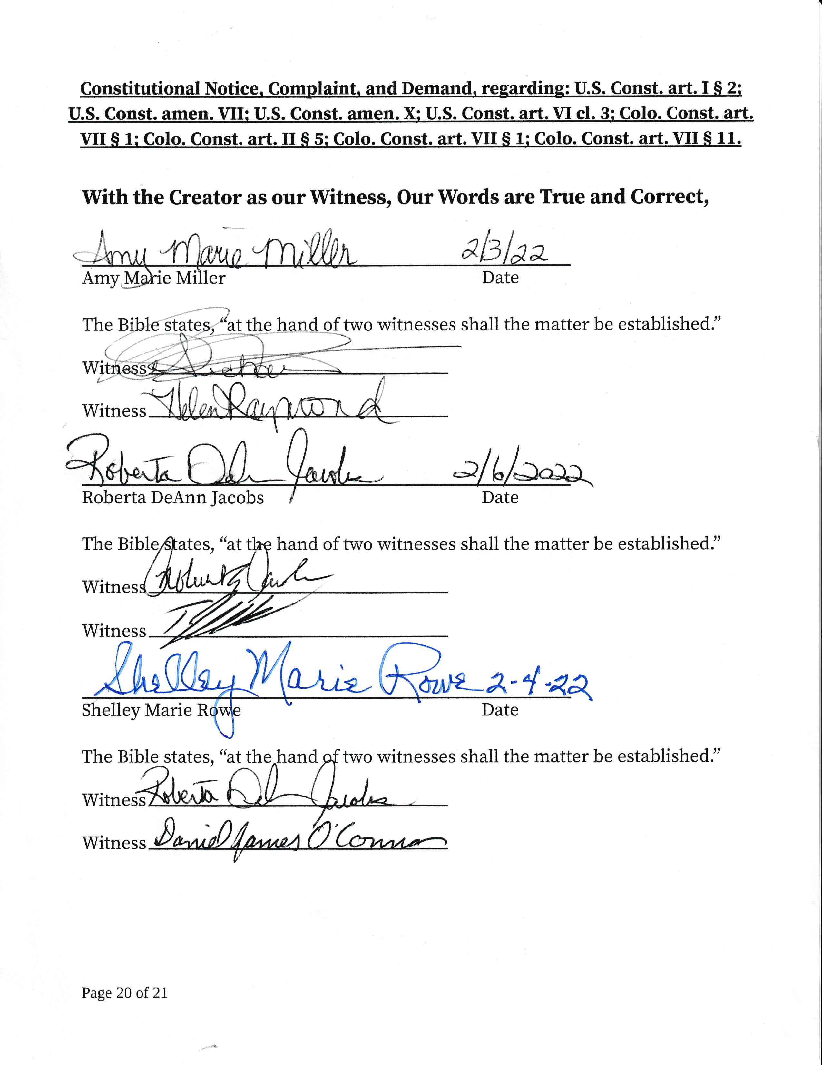
With the Creator as our Witness, Our Words are True and Correct,

Amy Marie Miller Date

The Bible states, “at the hand of two witnesses shall the matter be established.”

Witness

Witness

Roberta DeAnn Jacobs Date

The Bible states, “at the hand of two witnesses shall the matter be established.”

Witness

Witness

Shelley Marie Rowe Date

The Bible states, “at the hand of two witnesses shall the matter be established.”

Witness

Witness

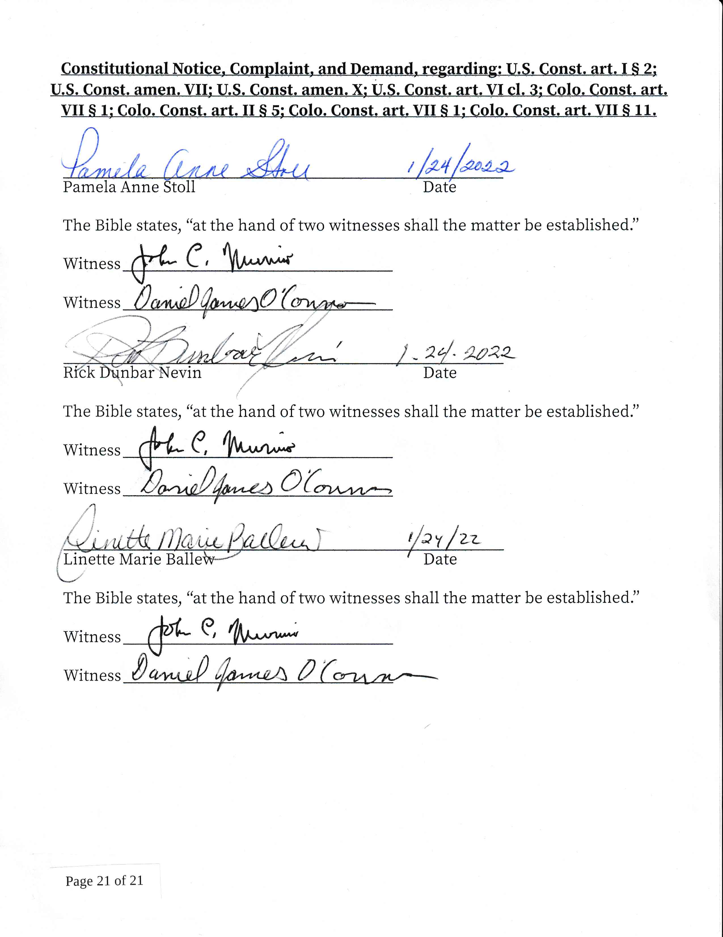

Pamela Anne Stoll Date

The Bible states, “at the hand of two witnesses shall the matter be established.”

Witness

Witness

Rick Dunbar Nevin Date

The Bible states, “at the hand of two witnesses shall the matter be established.”

Witness

Witness

Linette Marie Ballew Date

The Bible states, “at the hand of two witnesses shall the matter be established.”

Witness

Witness

